

**Menu**

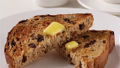

**All Day Breakfast:**

* 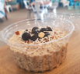Raisin Toast $3.00
* Overnight Oats $7.00
* Croissant + 2 fillings $7.50

**Sandwiches or Wraps:**

**Made Fresh to order**

Choice of toasted or fresh, GF options available

(Ham & Cheese, Banana or Strawberry with Nutella & Cream)

* A sandwich on a plate

  Description automatically generatedEgg & Bacon Wrap $8.00

Egg, Bacon, Cheese, BBQ Sauce & Mayo

Create your own: **Base + 2 Salads**

*Starting from $7*

Bases:

$1.50 - Ham, Chicken, Silverside, Tuna

$1.00 - Egg, Cheese

Salads:

$0.50 - Lettuce, Tomato, Cucumber, Capsicum, Beetroot, Pickles, Sauerkraut, Onion, Mushroom

$1.50 - Avocado

Sauces:

Tomato, BBQ, Mayonnaise, Garlic & Truffle Aioli,

Thousand Island Dressing, Smokey Chipotle, Honey

Dijon

* Ciabatta Breakfast Roll $8.50

Egg, Bacon, & BBQ relish

* Gourmet Ciabatta Brekky Roll $9.50

Egg, Bacon, Baby spinach, BBQ relish & Hollandaise Sauce

* Pancakes $12.50

(With maple syrup & your choice of strawberries or banana)

* Bacon & Eggs on Smashed Avo $14.00

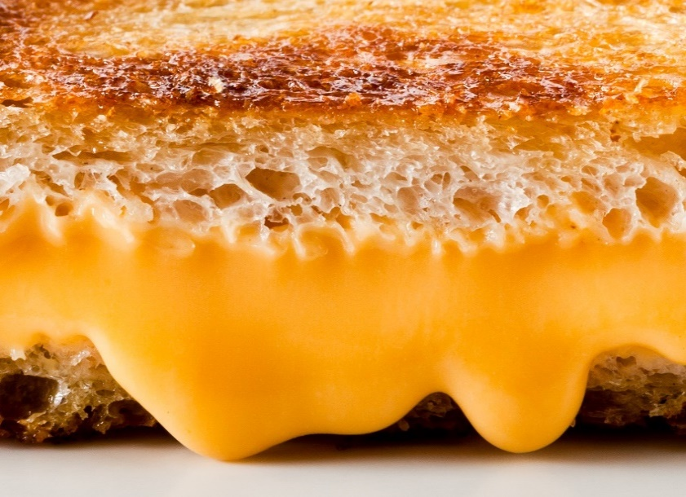On Turkish Bread (GF available)

**Toasted Sandwiches:**

* 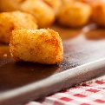Cheese & Tomato $7.00

**Snacks & Sides**

* Zaatar & 2 Cheese’s $7.50
* Ham & Cheese $7.50
* Cheese & Bacon Scones $4.50
* Vegetable Frittata $5.00
* Side Salad $3.00
* Side of Potato Gems $3.50
* Ham, Cheese & Tomato $8.00
* Ham, Cheese & Pineapple $8.00
* A plate of food on a table

  Description automatically generatedChicken, Cheese & Avocado $9.00
* Reuben(Silverside, Swiss Cheese, Sauerkraut) $9.50

**Sweets:**

**Please see selection in fridge for more**

**Light Meals:**

* Scones with Jam & Cream $5.00

GF Available

* Boterkoek (Dutch shortbread) $2.50

GF Available

* Macarons GF $3.00
* Protein Balls (GF, DF & Sugar Free) $3.50
* Lemon Slice $4.50
* Chocolate Fudge Brownie $4.50
* Fruit Slice $4.50
* Muffins see display for flavours $5.00
* Madeleines $5.00
* Banana Bread $5.00
* Sweet Chilli Chicken Wrap $8.00
* Sloppy Joe Savoury Mince in a roll $8.00
* Quiche & Salad Lorraine or Veggie GF $8.50
* A burger on a plate

  Description automatically generatedCheeseburger $8.50
* Beef Burger $9.00
* Chicken Burger $9.00
* Vegetarian Burger $9.50
* Tomato & Feta on Smashed Avo $12.50

On Turkish with balsamic glaze (GF Turkish available)

* Salt& Pepper Squid & Salad $13.50

**Drinks Menu**

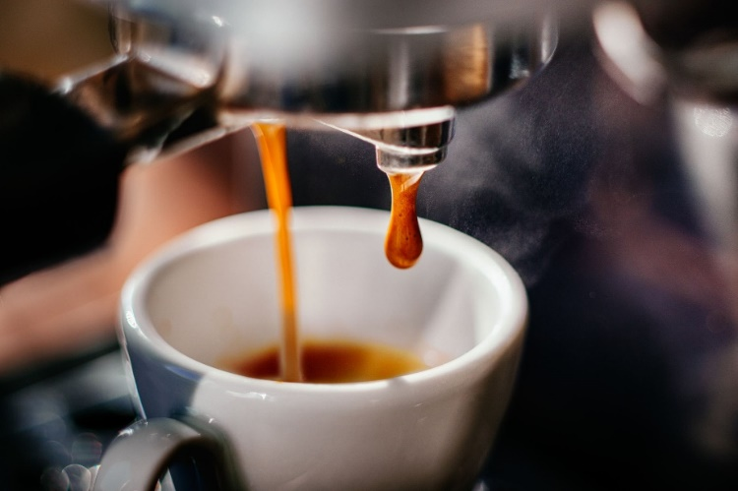

**Hot Drinks:**

* **Espresso $4.50**
* **Babyccino $2.50**
* **Dine In: Cup $5.00**

**Glass $5.50**

**Mug $6.00**

**Extra Shot: $1.00**

* **Take Away: Small $5.00**

**Medium $5.50**

**Large $6.00**

* Espresso
* Cappuccino
* Latte
* Flat White
* Long Black
* Mocha
* Chai Latte
* Hot Chocolate
* White Hot Chocolate
* Cup of Tea $4.50
* Pot of Tea $5.50

**Alternative Milks:** Skim, Soy, Almond, Oat, LF, Macadamia Coconut $0.50

**Syrup**: Vanilla, Caramel, Chai, Peppermint $0.50

Ginger, Hazelnut,

**Teas:** Black, Earl Grey, English Breakfast, Green, Peppermint, Chamomile, Lemon & Ginger, Dandelion, Rooibos, Chai

**Cold Drinks:**

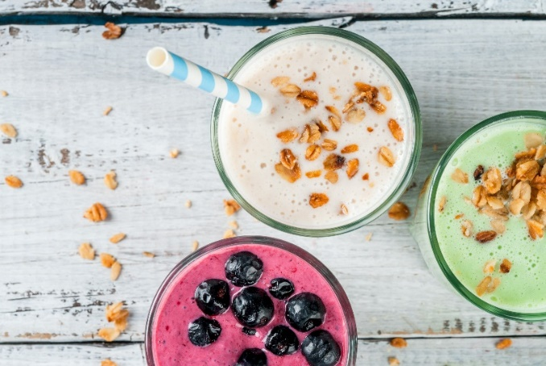

**Milkshakes:** Dine In: $6.50

Take Away: Sml: $6.00

Lge: $7.00

**Iced Drinks:** Dine In: $7.50 Take Away: Sml: $7.00

Lge: $8.00

**Frappe’s:** Dine In: $8.00 Take Away: Sml: $7.50

Lge: $8.50

Coffee Butterscotch

Mocha + $0.50 Caramel

Chocolate Banana

Vanilla Cookies & Cream

Strawberry Lime

White Chocolate

**Smoothies:** Dine In: $8.00

Take Away Sml: $7.50

Lge: $8.50

Banana – Frozen Banana, Milk, Greek Yoghurt, honey

Choc Banana – as above with chocolate syrup

**Selection of cold drinks from the fridge:**

Cans, Poppa Juice, Water $2.50

Iced Tea $4.80

Powerade $5.00

Juices & Bundaberg $5.00

Mixed Berry – Frozen mixed berries, milk, ice-cream, berry syrup

Tropical – Frozen Mango, pineapple, coconut milk, honey

Pine Lime – Frozen Pineapple, lime, Coconut milk, ice-cream

(Alternate Milks available + $0.50c)